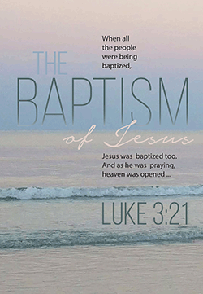
FAITH LUTHERAN CHURCH
The Baptism of Our Lord
Sunday, January 12, 2025
10:15 a.m.
Monday, January 13, 2025
6:30 p.m.
Luke 3:21 – “Now when all the people were baptized, and when Jesus also had been baptized and was praying ...” We know why the people were baptized, but why was Jesus baptized? He didn’t need repentance or forgiveness. The answer is that He did it for us. The reason God sent His Son into the world is to fulfill all righteousness for us, to do what we could not do. The whole of Jesus’ life, everything He did and said, was one great offering to the Father in our stead to fulfill all righteousness for us. With our righteousness fulfilled in Jesus and given to us in Baptism, our hearts now overflow with thanksgiving and praise.



WELCOME VISITORS: We extend a warm welcome to all our visitors today. We pray that your worship with us is rewarding. Please be sure to sign your name and address in our guest register, located in the narthex. If you are looking for a church home we would like to invite you to be a part of our Bible Based Church family.

Please TURN OFF ALL CELLPHONES before service begins. Phones that are on may interfere with transmission of the service to social media and shutting down your phone can help solve network connectivity problems.

PRINTED ORDER OF WORSHIP
Special Music –Ed Stiver

OPENING HYMN
“Baptized into Your Name Most Holy” LSB #590

INVOCATION
P Jesus said, “All authority in heaven and on earth has been given to me. Therefore, go and make disciples of all nations, baptizing them in the name of the Father and of the Son and of the Holy Spirit, and teaching them everything I have commanded you. And surely I am with you always, to the very end of the age.” (Matthew 28:18-20)
We begin our worship as we began our Christian life, through Holy Baptism, in the name of the Father and of the Son and of the Holy Spirit.
C Amen.

CONFESSION AND ABSOLUTION
P “God is spirit, and His worshipers must worship in spirit and in truth.” (John 4:24) And, “He who conceals his sins does not prosper, but whoever confesses and renounces them finds mercy. (Proverbs 28:13) Therefore, let us confess and renounce our sins with a sincere heart and mind before the Lord, receiving His Almighty, Divine, and Eternal forgiveness.

(A moment of silence
for personal confession and reflection.)

P We confess:
C God forgive me, a sinner. Most merciful God, we confess that we are by nature sinful and unclean. We have sinned against You in thought, word, and deed, by what we have done and by what we have left undone. We have not loved You with our whole heart; we have not loved our neighbors as ourselves. We justly deserve Your present and eternal punishment. For the sake of Your Son, Jesus Christ, have mercy on us. Forgive us, renew us, and lead us, so that we may delight in Your will and walk in Your ways to the glory of Your holy name. Amen.
P “For God so loved the world that He gave His only- begotten Son, so that whosoever believes in Him shall not perish, but shall have everlasting life. (John 3:16) “Blessed is the one whose sin the LORD does not count against him, and in whose spirit is no deceit. (Based on Psalm 32:1, 2) By this, your confession, I, by virtue of my office as a called and ordained servant of the Word, announce the grace of God unto you, and by the command and in the stead of the Lord Jesus Christ, (John 20:22-23; Matthew 16:19 NIV) I forgive you all your sins in the name of the Father and of the Son and of the Holy Spirit. “Be of good cheer, your sins are forgiven you. (Matthew 9:2 KJV) Now, go and live a life worthy of your calling in Christ Jesus, and produce fruit in keeping with real repentance. (Ephesians 4:1)

HYMN OF RESPONSE
“Father Welcomes” LSB #605

RESPONSIVE PSALM Psalm 29
P 1Ascribe to the Lord, O heavenly beings,
ascribe to the Lord glory and strength.
C 2Ascribe to the Lord the glory due his name;
worship the Lord in the splendor of holiness.
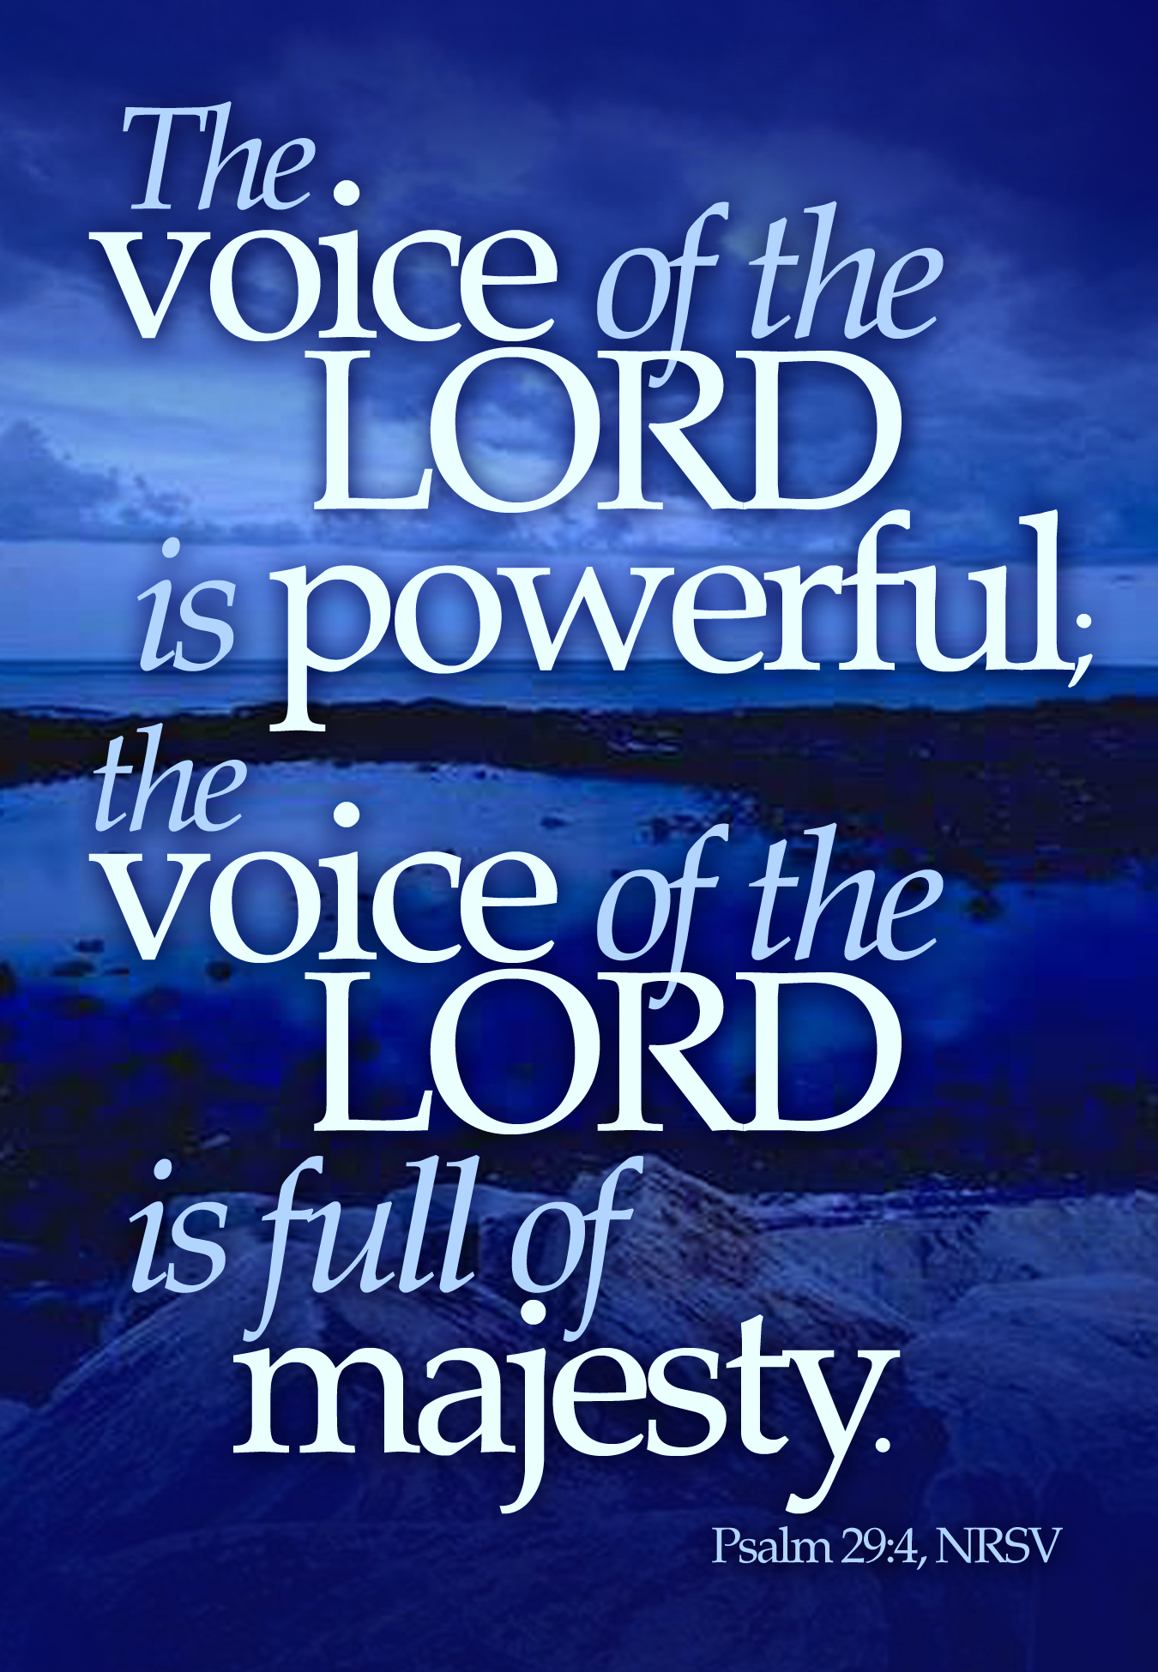
P 3The voice of the Lord is over the waters;
the God of glory thunders,
the Lord, over many waters.
C 4The voice of the Lord is powerful;
the voice of the Lord is full of majesty.
P 5The voice of the Lord breaks the cedars;
the Lord breaks the cedars of Lebanon.
C 6He makes Lebanon to skip like a calf,
and Sirion like a young wild ox.
P 7The voice of the Lord
flashes forth flames of fire.
C 8The voice of the Lord shakes the wilderness;
the Lord shakes the wilderness of Kadesh.
P 9The voice of the Lord makes the deer give birth
and strips the forests bare,
and in his temple all cry, “Glory!”
C 10The Lord sits enthroned over the flood;
the Lord sits enthroned as king forever.
P 11May the Lord give strength to his people!
May the Lord bless his people with peace!

GOD SPEAKS TO US THROUGH HIS HOLY WORD

P “For everything that was written in the past was written to teach us, so that through endurance and the encouragement of the Scriptures, we might have hope.
C “May the God who gives endurance and encouragement give you a spirit of unity among yourselves as you follow Christ Jesus, so that with one heart and mouth you may glorify the God and Father of our Lord Jesus Christ.” (Romans 15:4-6)

OLD TESTAMENT READING Genesis 17:9-14
⁹ Then God said to Abraham, “As for you, you must keep my covenant, you and your descendants after you for the generations to come. ¹⁰ This is my covenant with you and your descendants after you, the covenant you are to keep: Every male among you shall be circumcised. ¹¹ You are to undergo circumcision, and it will be the sign of the covenant between me and you. ¹² For the generations to come every male among you who is eight days old must be circumcised, including those born in your household or bought with money from a foreigner—those who are not your offspring. ¹³ Whether born in your household or bought with your money, they must be circumcised. My covenant in your flesh is to be an everlasting covenant. ¹⁴ Any uncircumcised male, who has not been circumcised in the flesh, will be cut off from his people; he has broken my covenant.”
P “The grass withers and the flowers fall,
C “but the Word of God stands forever.” (Isaiah 40:8)

SPECIAL MUSIC at Faith (Congregation Sings)
“Beautiful Star Of Bethlehem” Ed Stiver
1 Oh, beautiful star of Bethlehem
Shining far through shadows dimmed
Giving the light for those who long have gone
Guiding the Wise Men on their way
Unto the place where Jesus lay
Oh, beautiful star of Bethlehem, shine on

2 Oh, beautiful star, the hope of light
Guiding the pilgrims through the night
Over the mountains 'til the break of dawn
Into the land of perfect day
It will give out a lovely ray
Oh, beautiful star of Bethlehem, shine on
[Chorus]
Oh, beautiful star (Beautiful, beautiful star)
Of Bethlehem (Star of Bethlehem)
Shine upon us until the glory dawns
Give us the lamp to light the way
Unto the land of perfect day
Oh, beautiful star of Bethlehem, shine on

3 Oh, beautiful star, the hope of rest
For the redeemed, the good and the blessed
Yonder in glory when the crown is won
Jesus is now the star divine
Brighter and brighter He will shine
Oh, beautiful star of Bethlehem, shine on
[Chorus]
Oh, beautiful star (Beautiful, beautiful star)
Of Bethlehem (Star of Bethlehem)
Shine upon us until the glory dawns
Give us the lamp to light the way
Unto the land of perfect day
Oh, beautiful star of Bethlehem, shine on
Oh, beautiful star of Bethlehem, shine on
EPISTLE Colossians 2:8-15
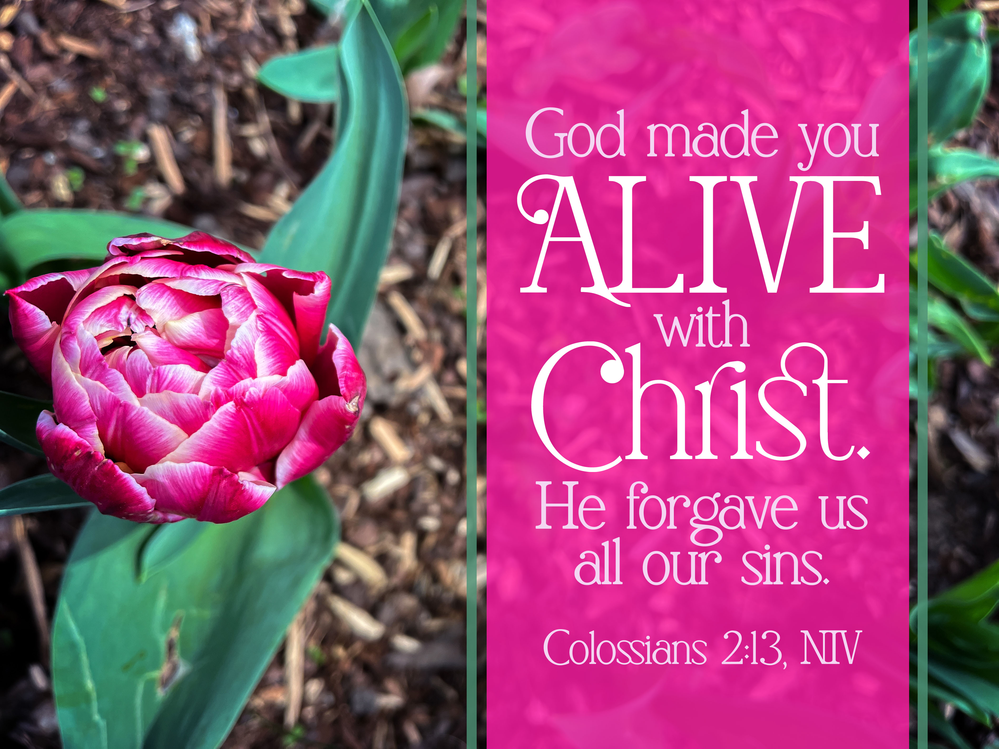
⁸ See to it that no one takes you captive by philosophy and empty deceit, according to human tradition, according to the elemental spirits of the world, and not according to Christ. ⁹ For in him the whole fullness of deity dwells bodily, ¹⁰ and you have been filled in him, who is the head of all rule and authority. ¹¹ In him also you were circumcised with a circumcision made without hands, by putting off the body of the flesh, by the circumcision of Christ, ¹² having been buried with him in baptism, in which you were also raised with him through faith in the powerful working of God, who raised him from the dead. ¹³ And you, who were dead in your trespasses and the uncircumcision of your flesh, God made alive together with him, having forgiven us all our trespasses, ¹⁴ by canceling the record of debt that stood against us with its legal demands. This he set aside, nailing it to the cross. ¹⁵ He disarmed the rulers and authorities and put them to open shame, by triumphing over them in him.

P “And we also thank God continually because, when you received the word of God, which you received from us, you accepted it, not as the word of men,
C “but as it actually is, the Word of God, which is at work in you who believe.” (1 Thess. 2:13-14)

HOLY GOSPEL Luke 3:15–22

15As the people were in expectation, and all were questioning in their hearts concerning John, whether he might be the Christ, 16John answered them all, saying, “I baptize you with water, but he who is mightier than I is coming, the strap of whose sandals I am not worthy to untie. He will baptize you with the Holy Spirit and with fire. 17His winnowing fork is in his hand, to clear his threshing floor and to gather the wheat into his barn, but the chaff he will burn with unquenchable fire.”
18So with many other exhortations he preached good news to the people. 19But Herod the tetrarch, who had been reproved by him for Herodias, his brother’s wife, and for all the evil things that Herod had done, 20added this to them all, that he locked up John in prison.
21Now when all the people were baptized, and when Jesus also had been baptized and was praying, the heavens were opened, 22and the Holy Spirit descended on him in bodily form, like a dove; and a voice came from heaven, “You are my beloved Son; with you I am well pleased.”

P “As Jesus was saying these things, a woman in the crowd called out, ‘Blessed is the mother who gave you birth and nursed you.’
C “He replied, ‘Blessed rather are those who hear the word of God, and obey it.’” (Luke11:27-28)

SERMON HYMN
“God’s Own Child, I Gladly Say It” LSB #594

SERMON

THE APOSTLES’ CREED

WE BRING OUR FIRSTFRUITS TO THE LORD

OFFERTORY RESPONSE
“Give Thanks With a Grateful Heart” LSB #806

THE FAMILY OF GOD PRAYS TOGETHER

THE LORD’S PRAYER
P Taught by our Lord and trusting His promises, we are bold to pray:
C Our Father who art in heaven, hallowed be Thy name, Thy kingdom come, Thy will be done on earth as it is in heaven; give us this day our daily bread; and forgive us our trespasses as we forgive those who trespass against us; and lead us not into temptation, but deliver us from evil. For Thine is the kingdom and the power and the glory forever and ever. Amen.

THE BENEDICTION
P The Lord bless you and keep you.
The Lord make His face shine on you and be gracious to you.
The Lord look upon you with favor and † give you peace.
C Amen.

CLOSING HYMN
“All Christians Who Have Been Baptized” LSB ##596

BIBLE READINGS
Sunday: Ezekiel 34:1-24; Romans 3:19-31
Monday: Ezekiel 36:13-28; Romans 4:1-25
Tuesday: Ezekiel 36:33 – 37:14; Romans 5:1-21
Wednesday: Ezekiel 37:15-28; Romans 6:1-23
Thursday: Ezekiel 38:1-23; Romans 7:1-20
Friday: Ezekiel 39:1-10, 17-29; Romans 7:21 – 8:17
Saturday: Ezekiel 40:1 – 42:20; 43:1-27; Romans 8:18-39

FAITH and ST. JOHN’S LUTHERAN CHURCHES
Please remember the following in your prayers:
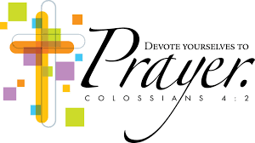
Gary Baumann Randy Braatz Rodney Dahlke Alice Fromm Wallace Emmerich
Sally Hannemann Angie Harkner Emma Hein Dale Janisch Cecelia & Lucille Klade
Rob Koebe Bruce Krenz Ron Lang Karen Love Debbie Olson Mark Pester Edgar Pfaff Marge Radenz Karen Rajek Jo Schedler Audrey Steckling
Lorraine Steckling Carl Uttech Deb Wiederhoeft Susie and Ellie Zastrow


CHURCH CALENDAR
ST. JOHN’S and FAITH

Sunday, January 12
8:30 a.m. Worship at St. John’s
Sunday School during Sermon at St. John’s
9:15 a.m. Sunday School at Faith
10:15 a.m. Worship at Faith
11:15 a.m. Bible Study at Faith
Monday, January 13
6:30 p.m. Worship at Faith
7:30 p.m. Budget Meeting at Faith
Tuesday, January 14
6:30 p.m. Dual Parish Meeting at Faith
Wednesday, January 15
5:30 p.m. Confirmation Class at Faith
Thursday, January 16
6:30 p.m. Bible Study at St. John’s
Sunday, January 19
8:30 a.m. Worship with Holy Communion at St. John’s
Sunday School during Sermon at St. John’s
9:15 a.m. Sunday School at Faith
10:15 a.m. Worship with Holy Communion at Faith
11:15 a.m. Bible Study at Faith
12:15 p.m. Evangelism/Stewardship Meeting at Faith
Monday, January 20
6:30 p.m. Worship with Holy Communion at Faith
Tuesday, January 21
6:00 p.m. Trustees’ Meeting at Faith
Wednesday, January 22
10:00 a.m. AbleLight Volunteers
5:30 p.m. Confirmation Class at Faith

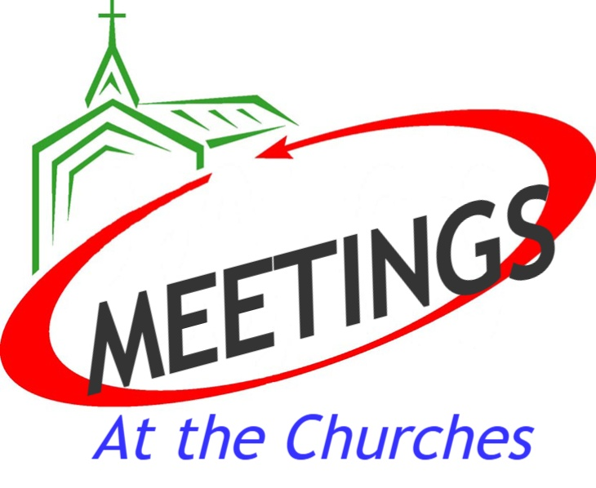
ST. JOHN’S
Tuesday, January 14
6:30 p.m. Dual Parish Meeting
at Faith

FAITH
Monday, January 13
7:30 p.m. Budget Meeting
Tuesday, January 14
6:30 p.m. Dual Parish Meeting at Faith
Sunday, January 19
12:15 p.m. Stewardship/Evangelism
Tuesday, January 21
6:00 p.m. Trustees’
Sunday, January 26
11:30 a.m. Annual Meeting


Board, Committee and Audit Reports for Faith should be in the church office by Wednesday, January 15 to have Annual Meeting Booklets ready by Sunday, January 19 for review.

LWML STAMPS FOR MISSIONS
The LWML collects used stamps to be sold to collectors. The Forever stamps are especially good. Trim them from the envelope with a 1/4" margin. There is a container on the south wall in St. John's Fellowship Room. At Faith, bring them to the church office.

Circuit Youth
Winter Games!
Come and join us for a fun-filled afternoon with the Merrill Circuit Youth! We’ll be playing volleyball,
dodgeball, and enjoying pizza together! Don’t miss out—bring your friends and
your game spirit! We can't wait to see you there!

Date: January 12 Time: 2:00 PM - 4:30 PM
Cost: $5 per person (for pizza)
Location: St. John Gym, Third Street, Merrill

ANNOUNCEMENTS
Thank You for your generous sacrificial offerings to the Lord, to help us keep our ministry going. You can also mail your offerings to Our Churches at
FAITH LUTHERAN CHURCH
15425 County Road K South
Merrill, WI 54452 or
ST. JOHN’S LUTHERAN CHURCH
134058 County Road L
Athens, WI 54411
(Please do not send hard cash through the mail)
Please help us spread the Word. Visit us online at Pastor’s (Don Love) Facebook Page, or Faith Lutheran Church, or on the church website at www.faithlutheranmerrill.com

